Mauritania

## Population Data

The data set shows the political stability estimate of the country each year.

## # A tibble: 23 x 5  
## country iso3c date population popCategory5  
## <chr> <chr> <dbl> <dbl> <chr>   
## 1 Mauritania MRT 1996 2372901 very small   
## 2 Mauritania MRT 1997 2433563 very small   
## 3 Mauritania MRT 1998 2496216 very small   
## 4 Mauritania MRT 1999 2561585 very small   
## 5 Mauritania MRT 2000 2630219 very small   
## 6 Mauritania MRT 2001 2702400 very small   
## 7 Mauritania MRT 2002 2778099 very small   
## 8 Mauritania MRT 2003 2857148 very small   
## 9 Mauritania MRT 2004 2939247 very small   
## 10 Mauritania MRT 2005 3024194 very small   
## 11 Mauritania MRT 2006 3111906 very small   
## 12 Mauritania MRT 2007 3202517 very small   
## 13 Mauritania MRT 2008 3296238 very small   
## 14 Mauritania MRT 2009 3393409 very small   
## 15 Mauritania MRT 2010 3494195 very small   
## 16 Mauritania MRT 2011 3598648 very small   
## 17 Mauritania MRT 2012 3706554 very small   
## 18 Mauritania MRT 2013 3817494 very small   
## 19 Mauritania MRT 2014 3930896 very small   
## 20 Mauritania MRT 2015 4046301 very small   
## 21 Mauritania MRT 2016 4163534 very small   
## 22 Mauritania MRT 2017 4282574 very small   
## 23 Mauritania MRT 2018 4403319 very small

# Population growth data

## # A tibble: 23 x 5  
## country iso3c date popGrowth popGrowthCat5   
## <chr> <chr> <dbl> <dbl> <chr>   
## 1 Mauritania MRT 1996 2.53 high growth rate  
## 2 Mauritania MRT 1997 2.52 high growth rate  
## 3 Mauritania MRT 1998 2.54 high growth rate  
## 4 Mauritania MRT 1999 2.59 high growth rate  
## 5 Mauritania MRT 2000 2.64 high growth rate  
## 6 Mauritania MRT 2001 2.71 high growth rate  
## 7 Mauritania MRT 2002 2.76 high growth rate  
## 8 Mauritania MRT 2003 2.81 high growth rate  
## 9 Mauritania MRT 2004 2.83 high growth rate  
## 10 Mauritania MRT 2005 2.85 high growth rate  
## 11 Mauritania MRT 2006 2.86 high growth rate  
## 12 Mauritania MRT 2007 2.87 high growth rate  
## 13 Mauritania MRT 2008 2.88 high growth rate  
## 14 Mauritania MRT 2009 2.91 high growth rate  
## 15 Mauritania MRT 2010 2.93 high growth rate  
## 16 Mauritania MRT 2011 2.95 high growth rate  
## 17 Mauritania MRT 2012 2.95 high growth rate  
## 18 Mauritania MRT 2013 2.95 high growth rate  
## 19 Mauritania MRT 2014 2.93 high growth rate  
## 20 Mauritania MRT 2015 2.89 high growth rate  
## 21 Mauritania MRT 2016 2.86 high growth rate  
## 22 Mauritania MRT 2017 2.82 high growth rate  
## 23 Mauritania MRT 2018 2.78 high growth rate

## Population trend

The plot shows the population trend of the country.

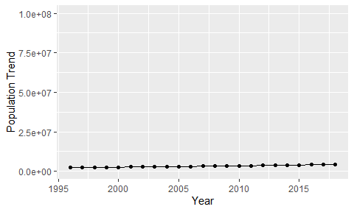

Political Stability Trend

# Population growth trend

The plot shows the population growth rate trend of the country.

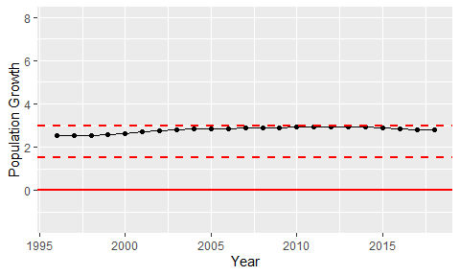

Population Growth Trend